**Table of Contents**

1. Project Summary
2. Conceptual Data Model Diagram
3. Tools Used
4. Data Dictionary
5. Logical Diagram
6. Business Rules
7. SQL Code
8. Application Screens
9. Team Log

**Project Name**

eCommerce Database Management System.

**Team Members**

Akshita Reddy, Maitreyi Ahire, Melita Coutinho, Vedant Patil

**Project Summary**

An e-commerce website project involves creating an online platform that allows customers to browse, select, purchase, and pay for products or services online. The project typically involves planning and research, design and development, testing and launch, marketing and promotion, and ongoing maintenance and updates. The success of an e-commerce website project relies on effective planning, development, ongoing maintenance, and a strong marketing and promotion strategy to drive traffic and sales.

The main idea of the project is to create a database for an online application to manage its records on customers, orders, payments, and shipments. This system will be helpful in the following ways:

* It efficiently stores, organizes, and retrieves data related to products, customers, orders.
* An eCommerce website usually has to deal with a lot of data which has to be stored and organized. This database system will be help smoothen this process.
* Accurate inventory management is highly required for an eCommerce platform as the inventory is constantly changing because products get added, sold, or restocked. Hence a good database management system is highly recommended.
* An eCommerce website generally receives numerous orders on day to day basis and these orders have to be processed quickly and accurately. An efficient DBMS can help achieve that.
* It will ensure Data security.
* Overall, this Database Management System will help solve the complex needs of an eCommerce website.

**Business Description**

The main idea of the project is to create a database for an online application to manage its records on customers, orders, payments, and shipments. This system will be helpful in the following ways:

* It efficiently stores, organizes, and retrieves data related to products, customers, orders.
* An eCommerce website usually has to deal with a lot of data which has to be stored and organized. This database system will help smoothen this process.
* Accurate inventory management is highly required for an eCommerce platform as the inventory is constantly changing because products get added, sold, or restocked. Hence a good database management system is highly recommended.
* An eCommerce website generally receives numerous orders on a day to day basis and these orders have to be processed quickly and accurately. An efficient DBMS can help achieve that.
* It will ensure Data security.

Overall, this Database Management System will help solve the complex needs of an eCommerce website.

**Problem Statement**

The problem is that the inventory records are only available in physical form, which makes it difficult to manage, maintain, and access. Paper records are prone to damage and loss, and the large volume of records takes up valuable space. This system also restricts customers from effectively tracking their orders. Therefore, there is a need for an online database system to address these and other issues like data security. Having a proper database management system will help with organizing data and records effectively.

**Proposed Solution**

With the use of this Ecommerce database, we can ensure improved User experience between all the users of this system as they can interact online and exchange information.

**Users**

Website administrators: They can handle the website's products, inventories, orders, and customer information using the eCommerce database system.  
Marketing teams: With access to client information from the eCommerce database system, they can develop individualized marketing campaigns, promotions, and recommendations.

Customer care: Employees can quickly and effectively respond to client complaints or questions by using the eCommerce database system to obtain customer information and order history.

Data analysts: They may access and evaluate information about consumer behavior, product performance, and other crucial indicators using the eCommerce database system.

**Potential Entities and Attributes**

**PRODUCT**

* product ID
* product name
* description
* categoryprice
* stock level
* weight

**CUSTOMER ATTRIBUTE**

* customer ID
* name
* email address
* phone number
* shipping and billing addresses
* order history
* payment information

**ORDER**

* order ID
* customer ID
* product ID
* order date
* order status
* payment status
* shipping method
* shipping date

**Conceptual Data Model Diagram**

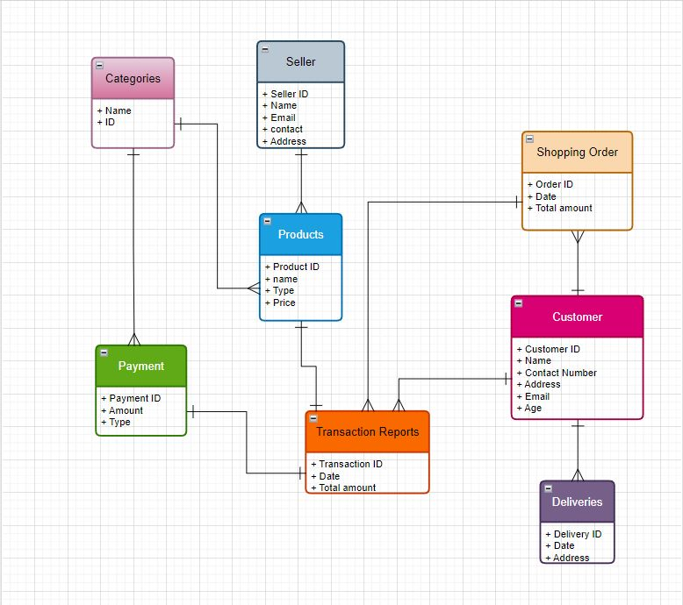

**Data Dictionary**

**Customers**

| Field | Data Type | Field Length | Constraints | Description |
| --- | --- | --- | --- | --- |
| customer_id | int |  | Primary key |  |
| customer_name | varchar | 50 |  |  |
| customer_email | varchar | 50 |  |  |
| customer_phone | int |  |  |  |
| address | varchar | 50 |  |  |

**Products**

| Field | Data Type | Field Length | Constraints | Description |
| --- | --- | --- | --- | --- |
| product_id | int |  | Primary key |  |
| product_name | varchar | 50 |  |  |
| product_type | varchar | 50 |  |  |
| product_category | varchar | 50 |  |  |
| category_id | int |  | Foreign key |  |

**Sellers**

| Field | Data Type | Field Length | Constraints | Description |
| --- | --- | --- | --- | --- |
| seller_id | int |  | Primary key |  |
| seller_name | varchar | 50 |  |  |
| seller_email | varchar | 50 |  |  |
| seller_phone | int |  |  |  |
| address | varchar | 50 |  |  |

**Orders**

| Field | Data Type | Field Length | Constraints | Description |
| --- | --- | --- | --- | --- |
| order_id | int |  | Primary key |  |
| order_date | date |  |  |  |
| order_delivery_date | date |  |  |  |
| order_status | varchar | 50 |  |  |
| order_seller_id | int |  | Foreign key |  |
| order_customer_id | int |  | Foreign key |  |
| order_product_id | int |  | Foreign key |  |

**Payments**

| Field | Data Type | Field Length | Constraints | Description |
| --- | --- | --- | --- | --- |
| payment_id | int |  | Primary key |  |
| payment_order_id | int |  | Foreign key |  |
| payment_date | date |  |  |  |
| payment_amount | int |  |  |  |
| payment_method | varchar | 50 |  |  |

**Categories**

| Field | Data Type | Field Length | Constraints | Description |
| --- | --- | --- | --- | --- |
| category_id | int |  | Primary key |  |
| category_name | varchar | 50 |  |  |

**Deliveries**

| Field | Data Type | Field Length | Constraints | Description |
| --- | --- | --- | --- | --- |
| delivery_id | int |  | Primary key |  |
| delivery_order_id | int |  | Foreign key |  |
| delivery_date | date |  |  |  |
| delivery_status | varchar | 50 |  |  |

**Logical Data Model**

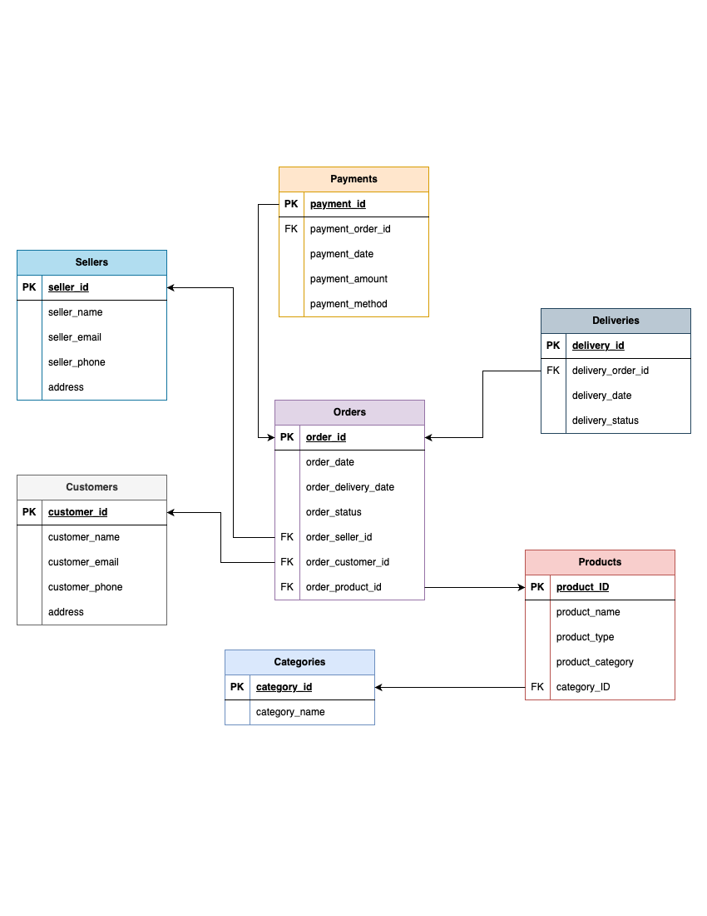

**Application Screens**

